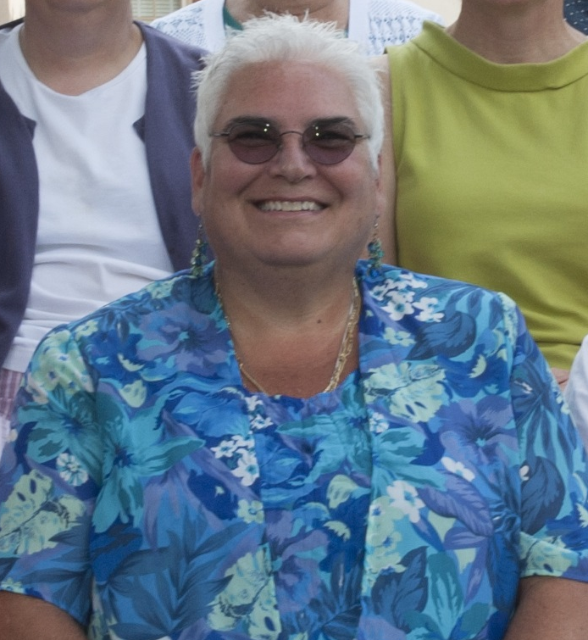

I’ve answered the call to be a hero!
Help me support the St. Baldrick’s Foundation.
March 10th @ 5:00 pm
Fatty McGees

138 Connetquot Avenue East Islip
I’m having my head shaved Saturday, March 10th to stand in solidarity with kids fighting cancer, but more importantly, to raise money to find cures. Since 2012, I have raised over $ 35,000 and with your support I know we can surpass that amount! Your gift will give hope to those fighting childhood cancers.

Think about this staggering fact: one out of every five children diagnosed with cancer will not survive – that’s one child too many. As an RN and a Mom, I have cared for children and their families facing the physical and emotional challenges of cancer. Cancer is a battle no family should have to deal with.
This is Juliana Massaro who fought her battle against ALL (Acute Lymphocytic Leukemia) with grace and that wonderful smile. She is our forever Angel at 9 years old and I am raising funds in her memory.
Please visit my web page for details and join me in my efforts to find a cure. Together we can make a difference.
http://www.stbaldricks.org/participants/mypage/944105/2018
Elisa A. Mancuso RNC-NIC, MS, FNS, AE-C
Professor of Nursing @ Suffolk County Community College mancuse@sunysuffolk.edu

